Introduction

Nowadays, online shopping is now a trend to all people around the world. Astrid Clothing Inc. offers a complete website, shopping cart, order management for selling band t-shirts. This online shop was launch on month of January 2013. It was created by a group of friends who loves to collect band shirts. The main market of Astrid Clothing Inc. is to sell band shirts from different foreign bands. The money collected will be given to a charity and to the orphanage.

Objectives

Astrid Clothing Inc. needs to:

* Having a working online shop.
* To able to have a user-friendly website
* To provide good service to all customers

Outline Screen Design

**Outline Design – Home Page / Shop**

LOGO

IMAGES

IMAGES

IMAGE

**Output Design – Home Page / Shop**

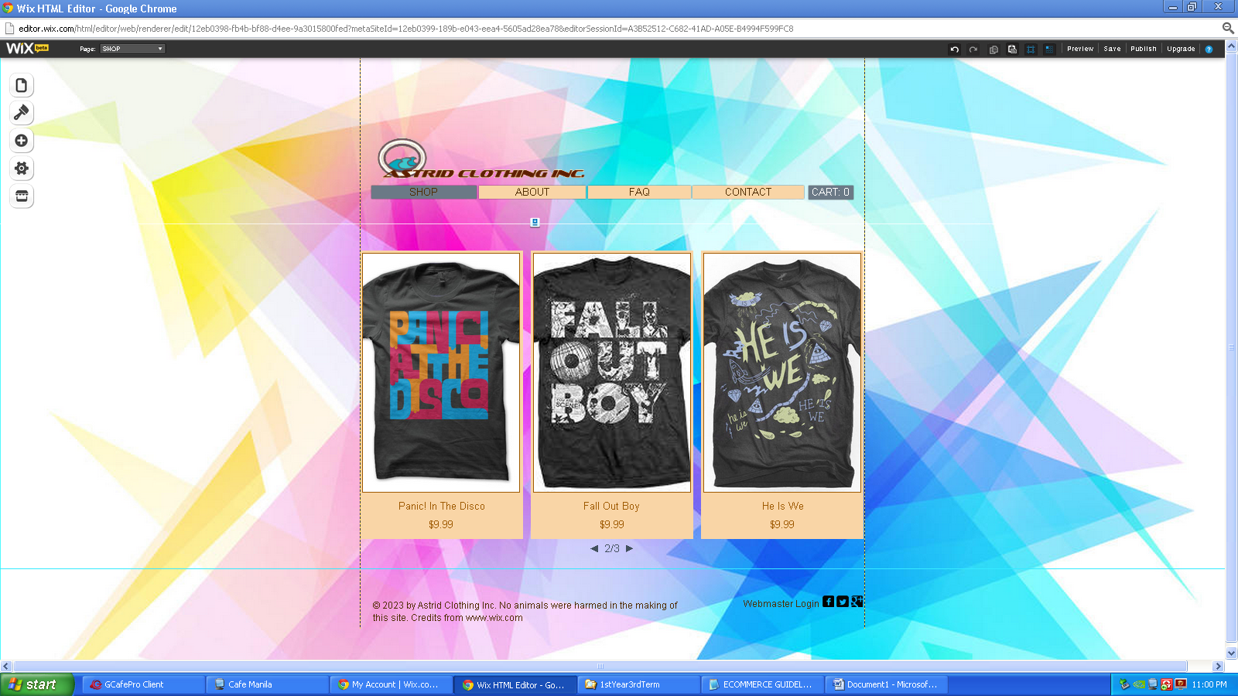

**Outline Design – About Us**

LOGO

TEXT

IMAGE

**Output Design – About Us**

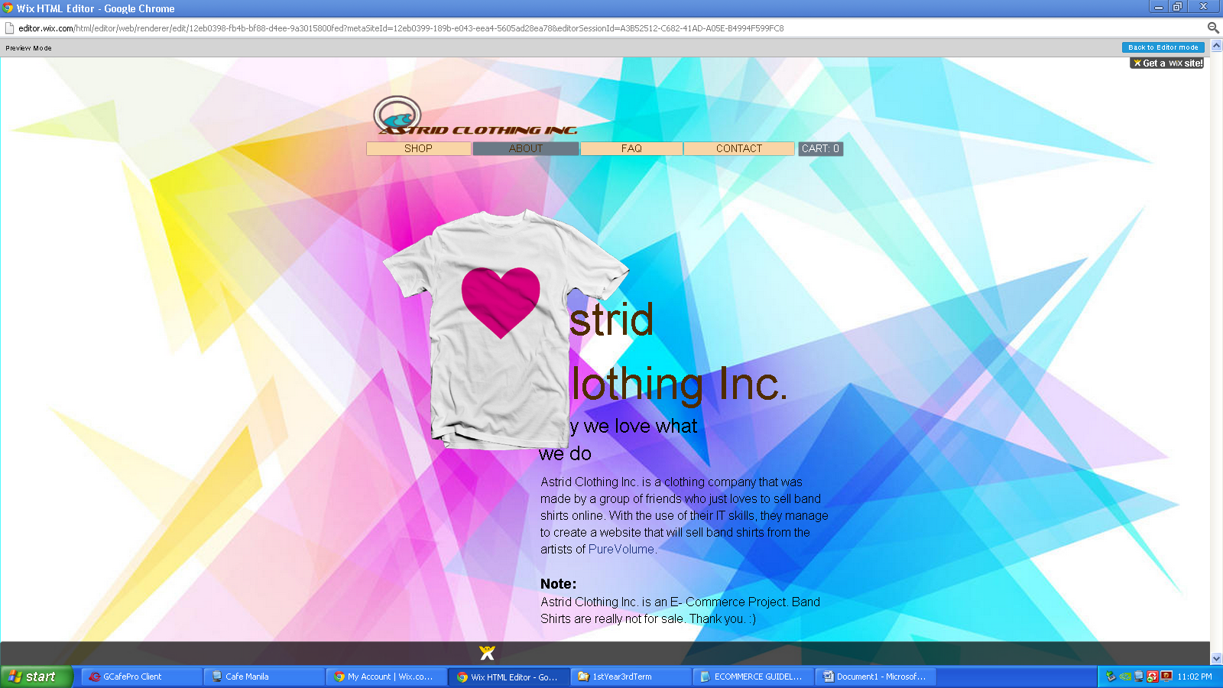

**Outline Design – FAQ**

LOGO

TEXT

**Output Design – FAQ**

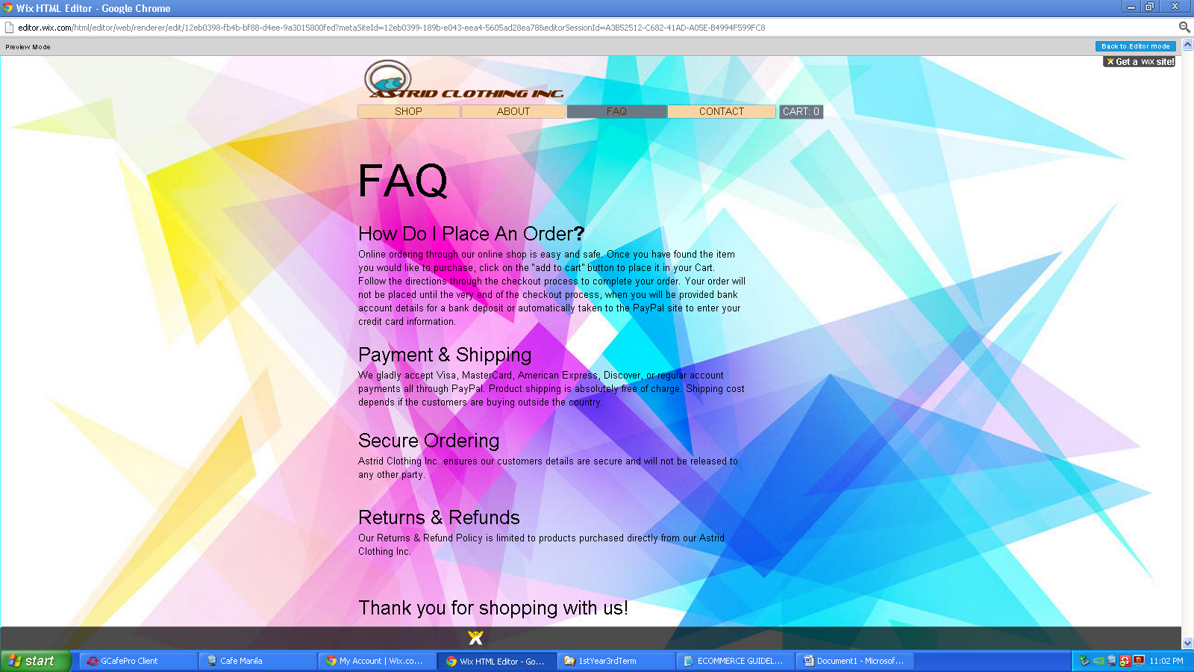

**Output Design – Contact**

LOGO

Details

**Output Design – G**

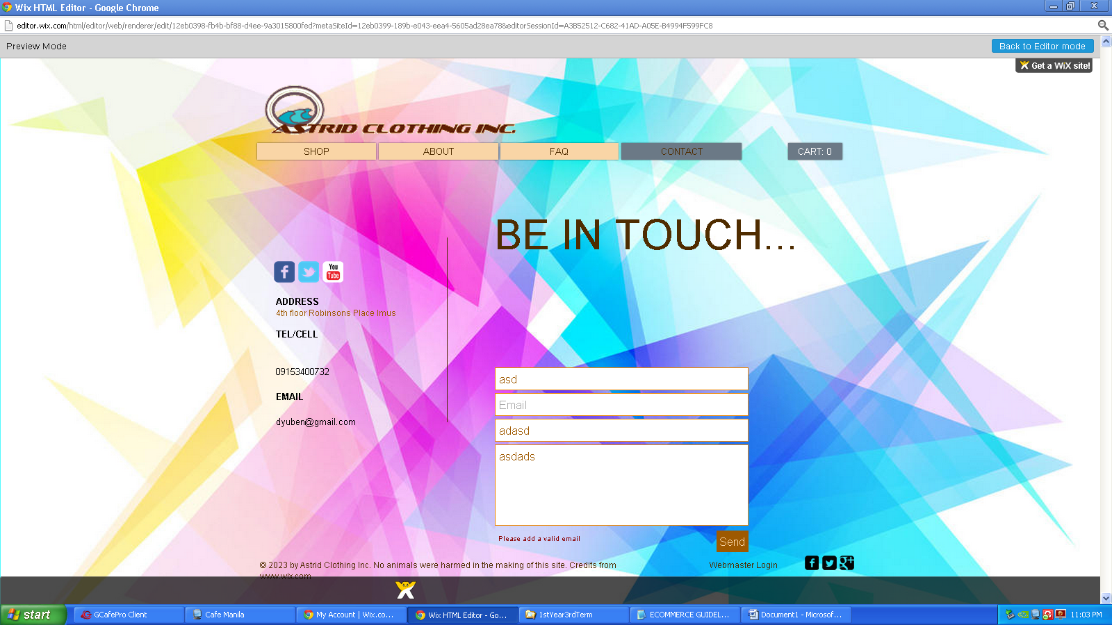

**Output Design – Cart**

LOGO

**Output Design – Cart**

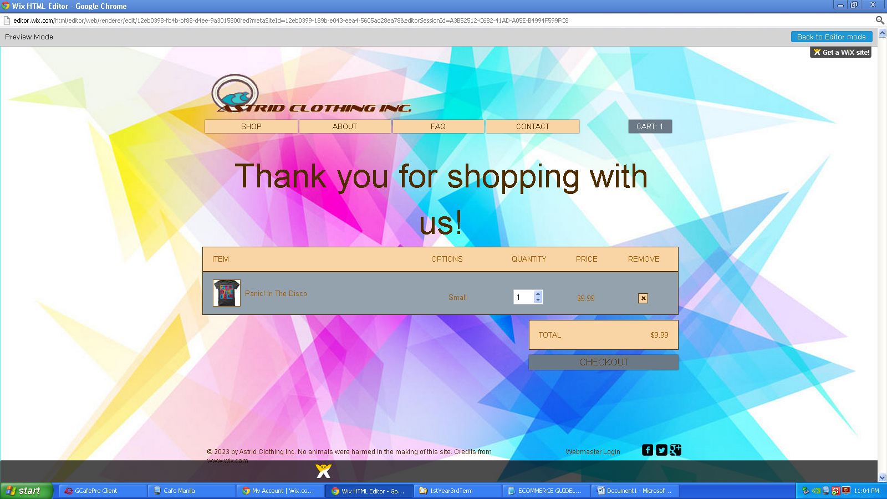

Proposed and Current System Expenses

# Hardware Cost

Monitor: 17.3” FULL HD 16:9 Ratio, 1920X1080 LED Backlit

Keyboard: Razer™ Anti-Ghosting Keyboard

Mouse: Roccat Kone Pure

CPU: Intel® Core™ i7 Quad Core Processor with Hyper-Threading 2.2GHz (Base)/3.2GHz (Turbo)

Total: 109,939.16 PHP / $2,569.98

# Software Cost

Operating System: Windows 7

Site Development: [www.wix.com](http://www.wix.com), Adobe Photoshop CS5

Marketing Strategy: Banner – [www.logomaker.com](http://www.logomaker.com)

Total: Free

# Other Requirements Cost

Globe Telecom 3Mbps: 2,299.00 PHP

Web Hosting Facility

Astrid Clothing Inc. website was made in Wix. It is a free online platform that allows users to create HTML5 websites, mobile sites, and Facebook pages through the use of “Drag and Drop” tools. Users are able to add different third-party application to their websites such as contact forms, music players and more. You will only need to register an account before you can create your first HTML5 website. For the beginners in creating HTML5 websites, Wix can be useful for you because it has video tutorials that you can watch.



Free Web Hosting Procedure

After you register in WiX, you can now edit your own website as you can see below; your tools are just right beside the screen which you can use for upgrading your website. If you are finished, you can now save then publish your work.

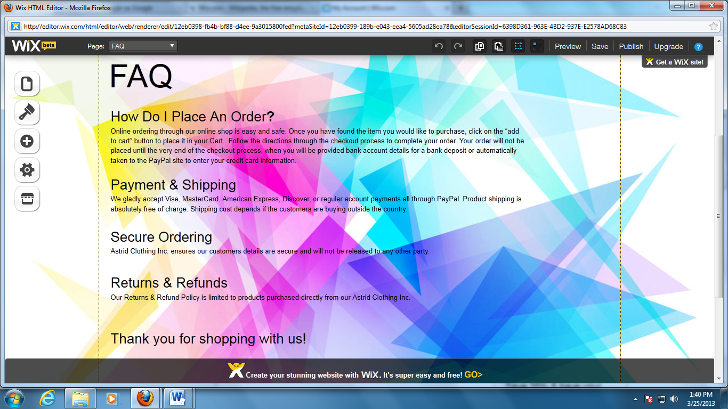

Site Development

For the cart view, you can adjust the value of the quantity. Quantity depends in how many the stacks in the storage. You can remove a product by pressing “x”. After that, you can see the total of the product then you can check out.

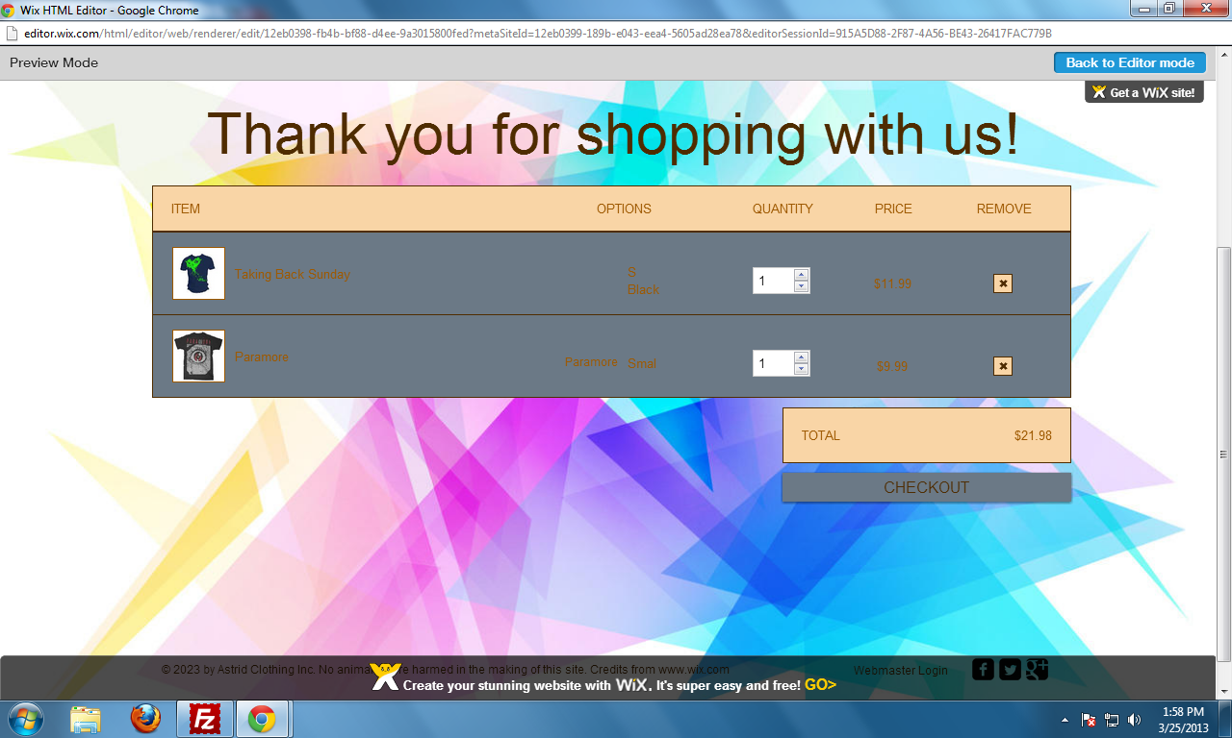

Physical Design (Intranet)

 

 

 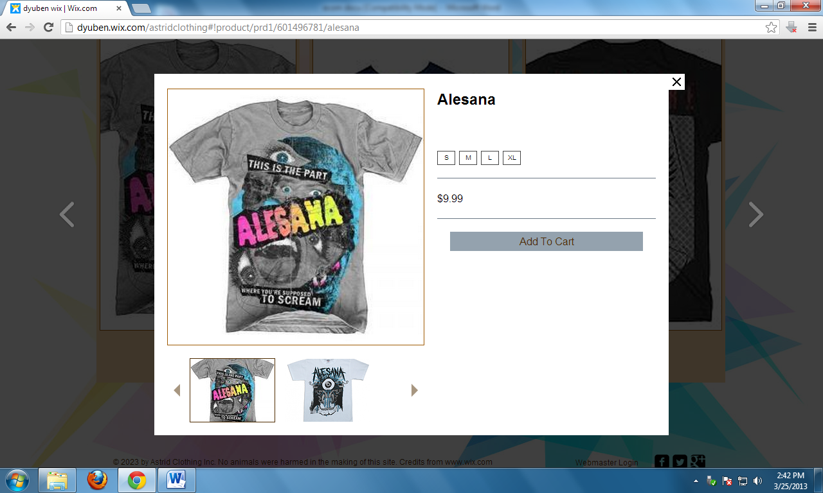

Security Plan

# Firewall

A firewall program can either be software-based or hardware-based and is used to help keep a system protected. Its main purpose is to management the inbound and confident system visitors by examining the information packages and identifying whether it should be permitted through or not, depending on a pre-specified concept set. A system's firewall program creates a link between the inner system or pc it defends, upon obtaining that the other system is protected and reliable, usually an exterior (inter)network, such as the Internet, that is not presumed to be protected and reliable.

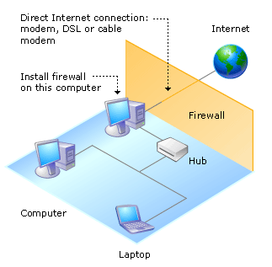

Conclusion

**Strengths**

This website is very easy to navigate.

**Weakness**

This website is made from [www.wix.com](http://www.wix.com) though it is a free web designing swebsite; it is not good for big business.

**Enhancements**

This website needs more products and entertainment like music, art, bands, etc.

# References:

[www.wix.com](http://www.wix.com)

<http://en.wikipedia.org/wiki/Firewall_%28computing%29>

[www.logomaker.com](http://www.logomaker.com)

<http://pixlr.com/editor/>